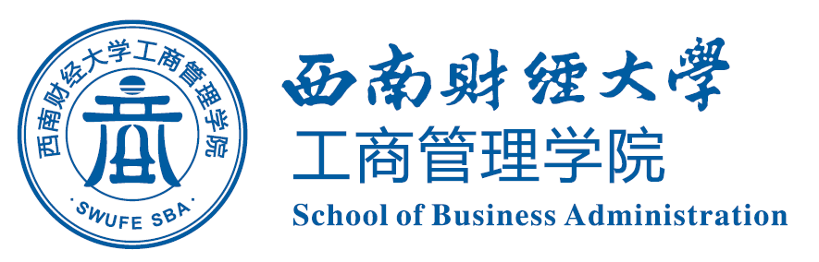


NEWSLETTER

SBA SWUFE

Index
The First Online Lecture, "Corporate Finance" —Learn in Order to Practise of Lecture Series "Dialogue with Corporate Executives" Held Successfully.....................................1

SWUFE Delegations being awarded the Second and Third Prize
in National Supply Chain Contest…………………………………………………………………....………..2

The Second Online Lecture, " Organizational Structure " —Learn in Order to Practise of
Lecture Series "Dialogue with Corporate Executives" Held Successfully………………………………3

The Third Online Lecture, " Financial Service Innovation: Empowering Technology and Embracing the Future " —Learn in Order to Practise of Lecture Series "Dialogue with Corporate Executives" Held Successfully……………………………………………………………………4

International Affairs Office and Sino-French Innovation Research Center
School of Business Administration
Southwestern University of Finance and Economics

April 2020

NEWSLETTER

The First Online Lecture, "Corporate Finance" —Learn in Order to Practise of Lecture Series "Dialogue with Corporate Executives" Held Successfully

On the afternoon of April 14th, hosted by the Nantes Project Office of SBA, SWUFE，the first lecture, "Corporate Finance" —learn in order to practise of lecture series "Dialogue with Corporate Executives" began. Ms. Hu Xiaomin, Master of the University of South Dakota, General Manager of Chengdu Elite Zhiyuan Management of Entrepreneur and investment Co., Ltd., and CFA Chartered Financial Analyst Holder, was invited as the lecture speaker. With provincial-level health industry guidance funds, listed companies and the Big Four accounting firms working experience, Manager Hu accesses sharp observation in strategic planning, due diligence, capital management and financial control.
Manager Hu firstly shared the practical application of the company's financial knowledge in the enterprise. Then focused on the positioning and selection of career planning, Manager Hu subdivided the financial professions, connected her personal interests with financial skills through analyzing one’s interest, skills and development trend, and indicated the direction and methods of career planning for SWUFE students. The lecture came to an end after the interactive Q & A session.
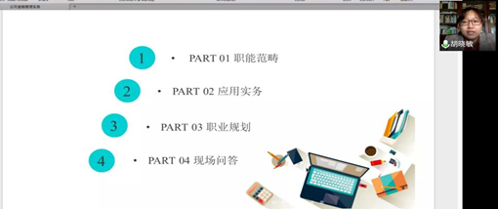
This lecture series on "Dialogue with Enterprise Executives" aims to broaden the horizons of joint BBA program students and improve their ability of knowledge application. Drawing on enterprise cases to explain the professional knowledge in the field of financial services, the lecture series invites well-known company executives, managers and industry experts as the keynote speakers to enhance students’ acquisition of knowledge, with the expectations of students being high-end financial services talents and business leaders imbued with solid professional knowledge and skills.

SWUFE Delegations being awarded the Second and Third Prize

in National Supply Chain Contest

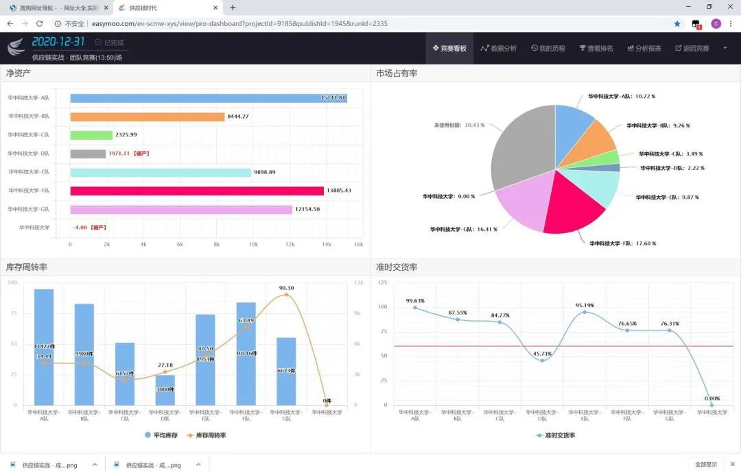
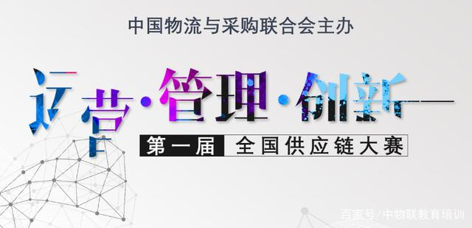
On April 19th, sponsored by China Federation of Logistics and Purchasing (CFLP), the first National Supply Chain Contest unveiled its mask. The comprehensive advantage evaluation and the ranking calculation was based on whether students skillfully applying theories in supply chain management to analyse market conditions, trends, cunstomer structures, distribution of sales territory, and to successfully solve the problems of plant layout, capacity of production, and composition of raw material suppliers, etc.
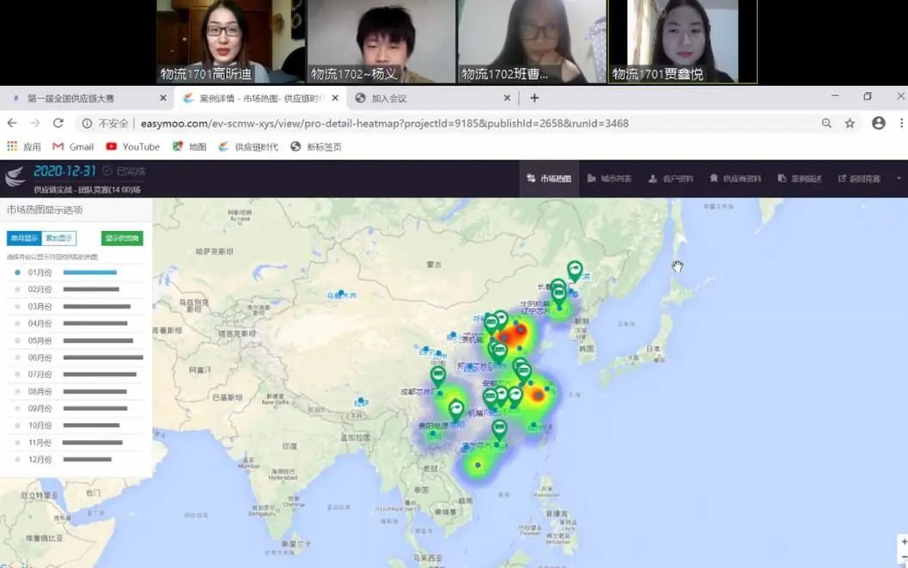
After fierce competition, the two delegations from SWUFE outperformed themselves in 549 bachelor-degree level delegations and was among the 271 teams entering into the semi-finals of this contest. After two days of painstaking efforts, one SWUFE delegation entered into the final with the other 39 ones. In the semi-final round, the two SWUFE delegations were awarded the second and third national prize by CFLP respectively.
The Faculty Director of Department of Logistics Management, Prof. Zhang Hanpeng, with Associate Prof. Li Feng and Associate Prof. Peng Bo gave professional training and direction to the delegates. During the competition, students from SWUFE benefited not only in professional knowledge of Supply Chain Management as well as the related areas, but also cultivated the ability of cooperation and critical thinking.

The Second Online Lecture, " Organizational Structure " —Learn in Order to Practise of Lecture Series "Dialogue with Corporate Executives" Held Successfully

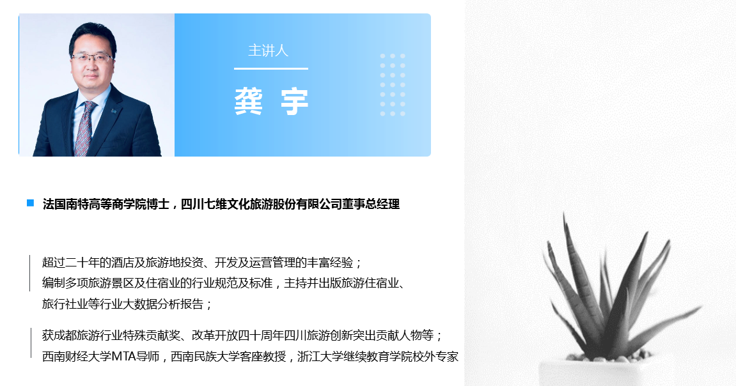
On the evening of April 23rd, hosted by the Nantes Project Office of SBA, SWUFE, the second lecture, “Organizational Structure”—learn in order to practise of lecture series “Dialogue with Corporate Executive” began. Mr. Gong Yu, PhD of Audencia Business School, General Manager of Sichuan Qiwei Culture Co., Ltd. and Mr. Huang Xiuhao, Master of South Western University of Finance and Economics, working in the Strategy Department of Qingdao Hai’er Zhijia Co., Ltd. were invited as the lecture speakers. Both of the two speakers shared their experience on the organizational structure change under public emergencies as well as its impact on enterprise staff.
In the first place, Mr. Huang Xiuhao expounded the micro-level influence of organizational structure on the enterprises. Based on his own working experience in smart operation of Hai’er Co., Ltd., Mr. Huang shared the strtegic revolution of Hai’er in recent years, and introduced the win-win business model called “Ren Dan He Yi”, which is a unique business model created by the Chief Excutive of Hai’er. It is different from the general competition and organization mode, and differentiates from the traditional business mode and profit mode. It adapts to the characteristics of the “zero distance”, “decentralization”, and “deintermediation” in this digital age.
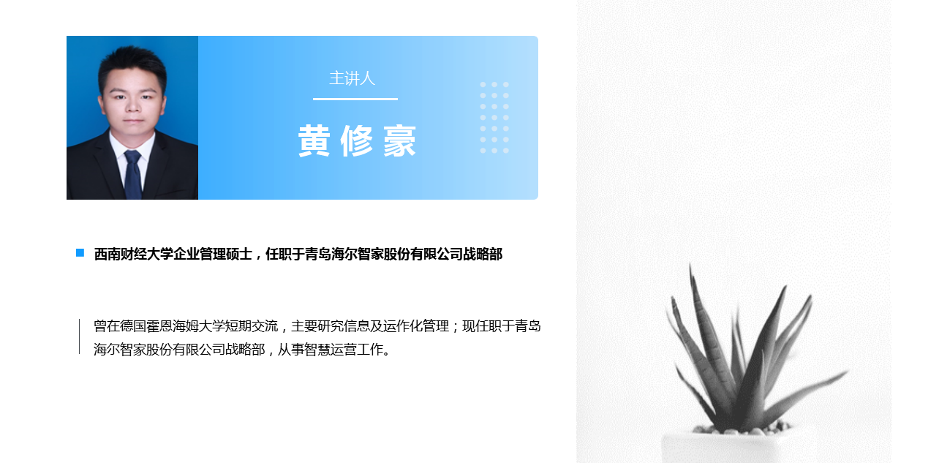
Then, combining this public health emergency, Mr. Gong Yu analysed the effect of COVID-19 on its enterprise and concluded that only an enterprise with flexibility and learning ability can deal with the emergency easily and swiftly.
This second lecture of the lecture series “Dialogue with Corporate Executive” enhanced students comprehension and expand their knowledge about the Travel Industry. Meanwhile, the students acquired not only proffesional knowledge and also the practical information in entrepreneurial management.

The Third Online Lecture, " Financial Service Innovation: Empowering Technology and Embracing the Future " —Learn in Order to Practise of Lecture Series "Dialogue with Corporate Executives" Held Successfully

On April 28th, the second lecture of the Learn in order to Practise of Lecture Series “Dialogue with Corporate Executives”, with the theme “Financial Service Innovation: Empowering Technology and Embracing the Future” was held successfully. Mr. Jin Jing, PhD of Zhe Jiang University and the group leader of Total Volume Group of CAITONG Securities Co., Ltd. was invited as the main speaker. Dr. Jin Jing, who has 8 years of woking experience in securities industry, is specialized in research of the macro strategy in the financial industry. Dr. Jin, having been working as the industry researcher in famous private placements during the past consecutive years, holds unique and insightful views about the innovation in financial service industry.
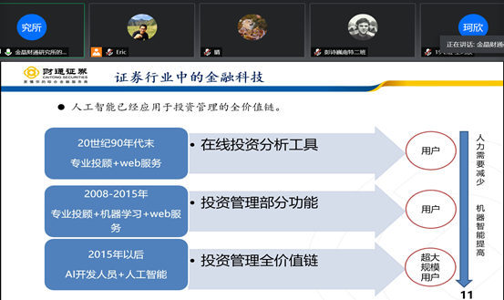
At the beginning of the lecture, Dr. Jin Jing made an interpretation on the main characteristics of financial service industry. Specifically, the financial service industry has distinguishing feature of regarding Banking, Insurance, Securities as well as Trust as the major industries, of relatively low investment in physical capital, of financing via agencies, and of labor-intensive working mode, etc. Apart from this, Dr. Jin Jing Pointed out that the financial service innovation from the enterprises is mainly on technological advancement.
Concretely speaking, while on-line trading and mobile terminal poperation promotes the development of financial service industry, simultaneously, the three new gadgets pose enormous impact on the traditional way of operation.
With the joining of some technological tycoons such as Alibaba and Tencent as well as the tremendous amount of capital invested in scientific research, the competition in financial service industry becomes increasingly, or even unprecedentedly fierce. Consequently, the burgeoning Internet-based financial service industry, which applies innovative technlogies of on-line payment, big data, and block chain, is developing rapidly and perfecting itself shortly. After sharing the above experience and professional views, Dr. Jin illustrated the opportunities and challenges of financial staff.
This third lecture of the lecture series “Dialogue with Corporate Executive” got appraised by students extensively. The lecture series also becomes an exclusive and innovative way of teaching by combing the practical entrepreneurial cases with professional knowledges, and showing the uniqueness of “learning for application, unifying knowledges and practice.

